Health and Safety Policy Statement
Health and Safety at Work etc. Act 1974
Ampfield Parish Council
Health and Safety Policy Statement
Ampfield Parish Council is committed at all times to comply with the health and safety legislation, to adopt industry best practise, as far as is practical, and to ensure that all aspects of the Council business take proper account of current health and safety requirements.
The Council’s general policy is:
- To seek to identify and provide appropriate control of the health and safety risks arising from Council activities
- To seek to identify risks, to prevent accidents and to maintain a safe and healthy working environment
- To seek to consult with our members, contractors, volunteers and employees on matters affecting their health and safety whilst they are engaged on Council activities
- To seek to provide health and safety related information/warnings to members of the public using/visiting our facilities or regarding Council activities that may otherwise affect them
- To provide appropriate information, instruction and supervision for volunteers/employees
- To seek to provide and maintain safe plant and equipment
- To seek to ensure safe handling and use of substances

This Health and Safety Policy Statement was approved by Ampfield Parish Council at its meeting dated 10th February 2020.
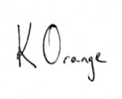
Signed: 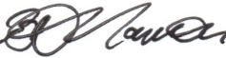 Chairman, Ampfield Parish Council
Signed: Clerk, Ampfield Parish Council
Date: 9 March 2020

Next review due: February 2024

